Modeling and Visualization of the COVID-19 Outbreak in Ontario

For

Bruno St-Aubin & Marian Radulescu



By

Sofia Bahmutsky

Kaitlyn Hobbs

Ngan Hien Lyle

Shreeram Murali

Data 599 - Capstone Project MDS

June 23, 2020



# Table of Contents

**Table of Contents** **2**

**1. Executive Summary** **4**

**\*\* briefly describe for The reader: 1) the background and focus of project; 2) the methods utilized in the project; 3) a summary of the results of the project and; 4) conclusions.** **4**

**2. Introduction** **5**

2.1 Background 5

2.2 Proposed Work / Deliverables 5

**3. Methods** **6**

3.1 Data Sources / Collection 6

3.2 Data Preparation / Tools 8

3.2.1 LTC data 8

3.2.2 PHU data 8

3.2.3 QGIS 8

3.3 Statistical Analysis Methods 8

3.3.1 LTC Statistics 8

3.3.2 PHU Statistics 8

3.4 Visualization Methods 8

**4. Interpretation of Results** **8**

4.1 LTC Homes Analysis 8

4.2 PHU Region Analysis 8

**5. Discussion** **8**

**6. Conclusions** **8**

**7. References** **8**

**8. Appendices** **9**

8.1 Appendix A - Methods 9

8.2 Appendix B - Results 10

8.3 Appendix C - Discussion 10

# 

# 

# 

# 

# 

# 

# 

# 

# 

# 

# 

# 

# 

# 1. Executive Summary

** briefly describe for The reader: 1) the background and focus of project; 2) the methods utilized in the project; 3) a summary of the results of the project and; 4) conclusions.

# 

# 

# 

# 

# 

# 

# 

# 2. Introduction

## 2.1 Background

Since its initial appearance in China on December 31, 2019, Coronavirus disease, or COVID-19, has evolved to a global pandemic - a novel disease to which there is little pre-existing immunity, that becomes epidemic in many countries. Worldwide, there are greater than 7 million confirmed cases and around 400,000 deaths (2). In Canada, there have been over 95,000 confirmed cases and in Ontario alone there have been more than 30,000 cases and nearly 2,500 deaths (3). Ontario is one of the Canadian provinces with the greatest amount of COVID-19 cases and fatalities. The COVID-19 virus can be transmitted between people primarily if an infected person breathes, coughs, or sneezes in close proximity to others. Symptoms may take up to 14 days to be noticable, and moreover, many individuals do not experience serious symptoms. This is cause for concern because people who may be unknowingly infected could be easily spreading the virus to others in their day-to-day activities. High-risk groups include: elderly individuals, immuno-compromised individuals, and people with other underlying health conditions such as COPD, asthma, diabetes, among others (4). It has become clear that seniors shoulder a disproportionate burden of disease. In fact, approximately 80% of COVID-19 fatalities in Canada are related to outbreaks among seniors in long term care (LTC) homes (?).

Various Ontario public health unit (PHU) regions have experienced different levels of COVID-19 activity. This may be related to characteristics of individual regions, such as proximity to amenities and prevalence of various health indicators. For example, northern Ontario regions are much less populated and urbanized than central Ontario regions, and this may be an influential factor which determines the extent of COVID-19 spread in a region.

Previous work on similar topics

List our research questions here...

## 2.2 Proposed Work / Deliverables

Based on the current events surrounding COVID-19 in Ontario and data which were available to us, an inferential approach was taken to investigate possible factors which may influence or contribute to the COVID-19 outbreaks in Ontario. This was accomplished by three main objectives:

* To produce an inferential statistical model of factors that may be associated with the COVID-19 outbreak in long-term care (LTC) homes in Ontario
* To produce an inferential statistical model of proximity and comorbidity factors that may be associated with COVID-19 outbreaks at the level of Public Health Units (PHU) regions in Ontario
* To produce an interactive dashboard using qGIS and D3 (Javascript) to visualize COVID-19 outbreak in combination with proximity and co-morbidity factors in Ontario.

# 

# 3. Methods

This project was completed over a period of 10 weeks, including proposal and final reporting included within this time frame. See appendix for schedule and weekly breakdown.

flowchart????

## 3.1 Data Sources / Collection

The data sources used in this project are all open-source and freely available. Some sources were sent directly to us by our capstone partner, others were obtained from Statistics Canada open databases, while other data was scraped from Ontario public websites. These are displayed below (Table X).

**Table X**. Summary of data used in the project methods. Table references the source of the data as well as the link to the data webpage if applicable.

|  |  |  |
| --- | --- | --- |
| **Data (name in project repository)** | **Source** | **Link** |
| Open Database for Health Facilities (ODHF) | Statistics Canada - LODE - Open Databases - Open Databases of Healthcare Facilities | <https://www.statcan.gc.ca/eng/lode/databases/odhf> |
| Dissemination Block ArcInfo shapefiles (used only in QGIS for methods, not included in repository) | Statistics Canada - Census Program - Geography - Boundary Files | <https://www12.statcan.gc.ca/census-recensement/alternative_alternatif.cfm?l=eng&dispext=zip&teng=ldb_000a16a_e.zip&k=%20%20%20215214&loc=http://www12.statcan.gc.ca/census-recensement/2011/geo/bound-limit/files-fichiers/2016/ldb_000a16a_e.zip> |
| Proximity Measures (PMD-en) | Statistics Canada - Data Visualization Products - Proximity Measures Data Viewer | <https://www150.statcan.gc.ca/n1/pub/71-607-x/71-607-x2020011-eng.htm> |
| ? LTC Data | Aggregation of web-scraped data from 3 public health Ontario websites | 1.<https://www.ontario.ca/page/how-ontario-is-responding-covid-19#section-1>  2.<http://publicreporting.ltchomes.net/en-ca/homeprofile.aspx?Home=c507&tab=0>  [3.www.hqontario.ca/System-Performance/Long-Term-Care-Sector-Performance](http://3.www.hqontario.ca/System-Performance/Long-Term-Care-Sector-Performance) |
| Comorbidities by Health Region (comorbidities) | Statistics Canada - Geospatial Explorer - Health Indicators | <https://www150.statcan.gc.ca/n1/pub/71-607-x/2020010/71-607-x2020app-eng.htm> |
| Ontario COVID-19 cases (ON_cases.csv) | Sent directly by Statistics Canada as csv | N/A |

## 3.2 Data Preparation / Tools

### 3.2.1 LTC data

### 3.2.2 PHU data

### 3.2.3 QGIS

## 3.3 Statistical Analysis Methods

### 3.3.1 LTC Statistics

### 3.3.2 PHU Statistics

## 3.4 Visualization Methods

# 4. Interpretation of Results

## 4.1 LTC Homes Analysis

## 4.2 PHU Region Analysis

# 5. Discussion

# 6. Conclusions

# 7. References

1. Dong, E., Du, H., & Gardner, L. (2020). An interactive web-based dashboard to track COVID-19 in real time. *Lancet Infect Dis*. https://doi.org/10.1016/S1473-3099(20)30120-1.
2. World Health Organization. (2020, March 3). Coronavirus disease 2019 (COVID-19) Situation Report – 42. Retrieved from <https://www.who.int/docs/default-source/coronaviruse/situation-reports/20200503-covid-19-sitrep-104.pdf?sfvrsn=53328f46_4>
3. Government of Ontario. (2020). How Ontario is responding to COVID-19. Retrieved from <https://www.ontario.ca/page/how-ontario-is-responding-covid-19>
4. Centers for Diseasse Control and Prevention. (2020). People who are at higher risk for severe illness. Retrieved from <https://www.cdc.gov/coronavirus/2019-ncov/need-extra-precautions/people-at-higher-risk.html>
5. Government of Ontario. (2020). Confirmed positive cases of COVID19 in Ontario. Retrieved from <https://data.ontario.ca/dataset/confirmed-positive-cases-of-covid-19-in-ontario/resource/455fd63b-603d-4608-8216-7d8647f43350>
6. Statistics Canada. (2020). ArcGIS REST Services Directory. Retrieved from <https://services1.arcgis.com/HsjBaDykC1mjhXz9/arcgis/rest/services/covid_19_by_health_regions_pro_view/FeatureServer>
7. Government of Ontario. (2020). How Ontario is responding to COVID-19. <https://www.ontario.ca/page/how-ontario-is-responding-covid-19>
8. Public Reporting for Long-Term Cares. Retrieved from <http://publicreporting.ltchomes.net/en-ca/LHIN_Map.aspx>

# 8. Appendices

## 8.1 Appendix A - Methods

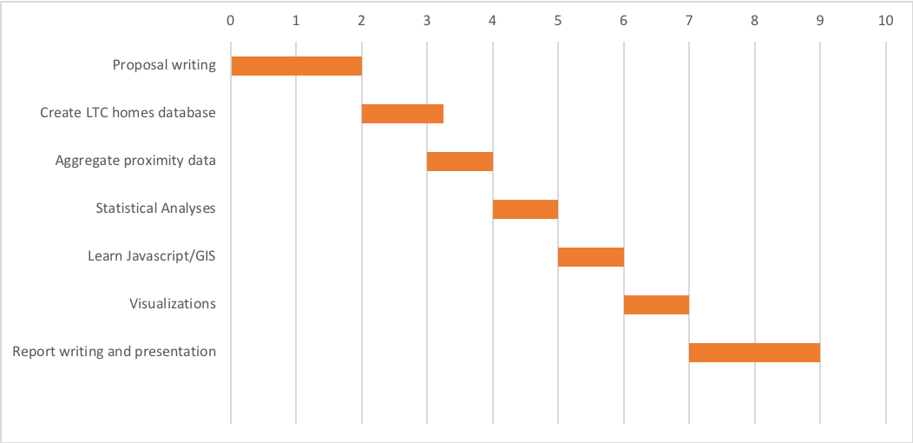

Figure X. Schedule of project tasks, broken down by weeks. April 26 to June 23 2020.

## 

## 8.2 Appendix B - Results

## 8.3 Appendix C - Discussion